General Surgery Residency Program
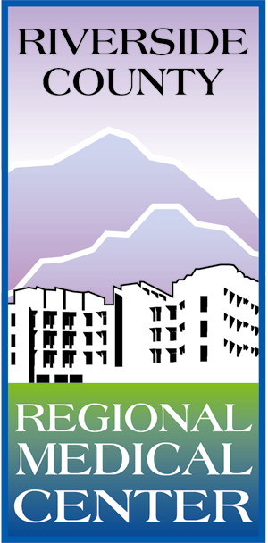
Research Requirement Approval Form

During the Surgical Education rotation, residents are required to meet with their mentor and begin exploring options for a research project. The research project should be one that can be presented at local, regional or national meetings or be published. The research project is to be complete by the end of your PGY 2 year. Please complete the form below and return it to Jenni Shieck no later than the end of the PGY 1 year.

Resident Name: _____________________________ Date: _______________________

Proposed Topic / Title: ______________________________________________________________

Goal of Research Project:______________________________________________________________
__________________________________________________________________________________
__________________________________________________________________________________

Current resources / literature on topic: _________________________________________________
_______________________________________________________________________________________________________________________________________________________________________

Projected completion date: ___________________________

Where are you going to submit research project (ie. What journals or meetings):
____________________________________________________________________________________

Signature of Resident Mentor: ________________________________________________________

After you have the above signatures, please submit this form to Jenni Shieck in the GME office.

Your Proposed Project Has Been Approved. □ Yes □ No

________________________________
Afshin Molkara, MD
Program Director
General Surgery Residency

